Assembly and Instructions
SAFETY INFORMATION
Please read and understand this entire manual before attempting to assemble, operate or install the product.
CAUTION: As with any large container of water, fountains are to be used carefully with adult supervision. They are not intended to be used as “kid pools” and present a risk to small children and infants. Injury or accidental drowning could result. In addition, as with any electrical appliance, make sure the pump plug is dry before you plug it into an outlet, and make sure you are not standing in the water - electrical shock could result. Filled fountain weighs a considerable amount. Make sure your set-up area can support at least 300 lbs.

For best results – Install the fountain on a flat, level surface close to an electrical outlet.
Place the fountain in a location where any water spills or splashing will not reach any other electrical equipment or cause damage.
Choose an appropriate location before installing the fountain. DO NOT lift or push/drag the water basin to relocate the fountain when it’s filled with water. Empty the water basin before lifting.
Excessive weight or pressure on any of the fountain sections may cause it to tip or fall over. Keep pets and children away from any of the fountain sections.
Some splashing may occur. To avoid injury from electrical shock, observe basic safety precautions and comply with the following instructions:
The pump on the fountain has no user serviceable parts. Only an authorized service representative should service the pump. Do not open the sealed pump housing as this may result in electrical shock. Refer to enclosed pump maintenance guide for cleaning.
- Always unplug the pump from the electric outlet before cleaning and handling.
- Use with clean water only. Do not place it in other liquids. Do not allow the pump to run dry.
- An adult should supervise children when they are around the pump.
- Use the proper power source as indicated on the pump label.
- Equip the electrical power for the pump with a ground fault circuit interrupter (GFCI).
- Keep the fountain away from high temperatures or heat sources.
- Do not use the pump in water above 86°F.
- Disconnect the power cord from the outlet by holding the plug. Do not lift, carry, or pull the pump by the power cord.
- If the entire fountain falls into the water accidentally, turn off the circuit breaker immediately.
- If any leakage occurs around the pump housing, turn off the circuit breaker immediately and have the pump serviced by a registered technician.
- Do not operate the fountain if the pump has been dropped or has a damaged power cord or plug. Do not replace the power cord.
- Keep the plug dry. Do not expose the plug to water or steam. Do not use the pump in swimming pool or marine area.
- If the plug or the wall receptacle gets wet due to water dripping down the power cord or for any other reason, do not remove the plug from the wall outlet until the circuit breaker is turned off.
NOTE: Allow the pump power cord to hang at a lower level than the wall outlet to form
a “drip loop.” This will help prevent water from dripping down the power cord and
getting into the wall outlet.

Page 1
- Do not expose the pump to direct sunlight or to low temperatures for any period of time.
- Use only a UL-approved extension cord of the correct rating to avoid overheating.
- Do not use attachments that are not provided by the manufacturer since they may cause an unsafe condition.
- Do not use the pump for anything other than its intended use.
ASSEMBLY INSTRUCTIONS
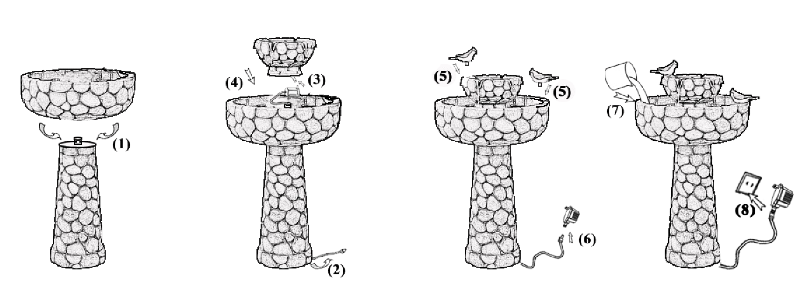
- Put the big bowl on to the pedestal and screw it tightly.
- Make the pump cable out from the bottom of pedestal.
- Connect the tube inside of the small bowl to the outlet of pump.
- Put the small bowl onto the big bowl.
- Insert the birds onto the bowls
- Connect the pump cable to the transformer.
- Gently pour water into the fountain, make sure the water completely submerges the pump.
- Plug into your local power supply.
CAUTION: Make sure there is no water on the plug.

CARE AND MAINTENANCE
- Check regularly that the water reservoir has sufficient water to cover the pump at all times. It will be necessary to check more frequently in warm or windy weather.
- Do not allow the pump to freeze. During cold spells, remove the pump from the water feature and place in a water-filled container in a frost-free position. DO NOT store the pump dry.
- Periodically it will be necessary to change the water and clean the water feature and reservoir. The frequency of this will depend on the weather and location of the water feature. The outside of the water feature can be cleaned using a soft cloth and clean water and the reservoir with a soft brush. A mild detergent can be used, but please note this will cause the water to foam and should be avoided unless strictly necessary.
- The pump rotor will require cleaning at approximately monthly intervals. A good indication will be if the water flow rate drops. Unplug the water feature, remove the pump from the water reservoir and disconnect the water pipe. Remove the filtering cover and pressure-casing from the front of pump body. Clean the rotor and housing in clean water using cotton buds. Reassemble the pump, reconnect the water pipe and reassemble the water feature.

Page 2
Outlet
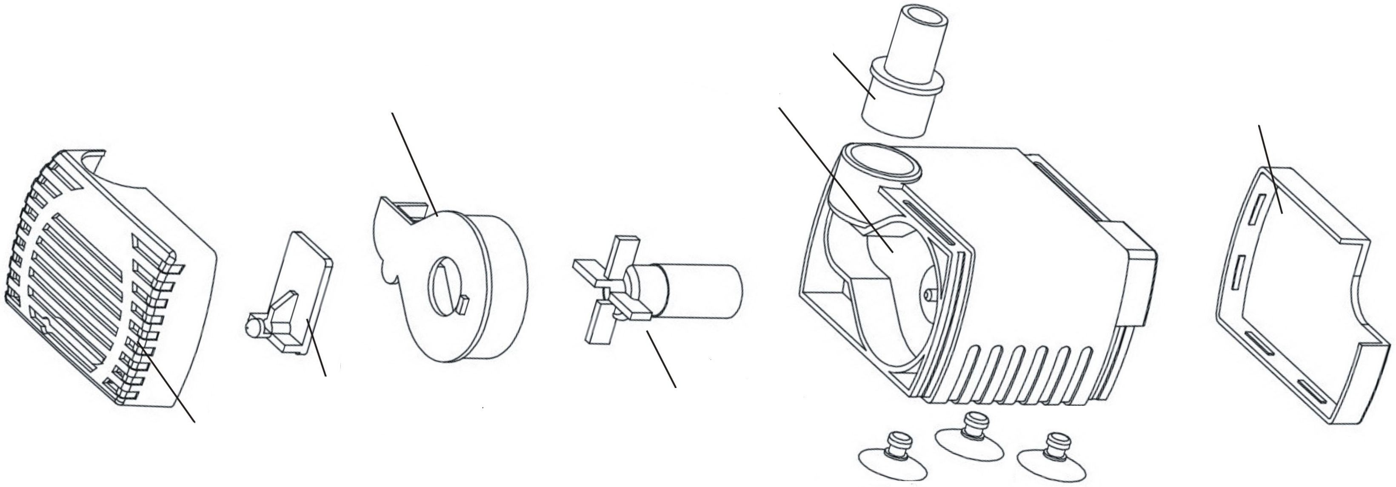
Pressure-Casing
Rotor
Filtering Cover
Control Valve
Pump Housing
Outer Cover
Absorb Cap

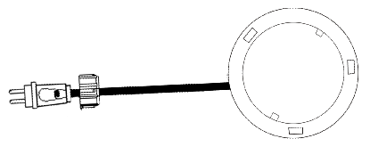
TROUBLESHOOTING

PROBLEM | POSSIBLE CAUSE | CORRECTIVE ACTION
Fountain is not pumping water. | - Pump is not covered with water.  - Pump or fountain is blocked.  - Pump is not secured correctly.  - Pump is not electrically connected.  - Pump may be “air locked.” | - Add more water to the reservoir.  - Disconnect fountain from power source, remove any obstruction, and clean bowl and tubing.  - Disconnect fountain from power source, pour out any remaining water, and ensure the tubing in the reservoir is tightly secured to the pump outlet.  - Check to make sure pump is plugged in and the outlet is working.  - Plug and unplug the pump several times to clear any air that may have been trapped.

SAVE THESE INSTRUCTIONS - THIS MANUAL CONTAINS IMPORTANT SAFETY AND OPERATING INSTRUCTIONS FOR POWER UNITS.

GLITZHOME CORPORATION (SHANGHAI), LTD.
Toll free 888-357-7263
customerservice@glitzhome.com
Page 3

